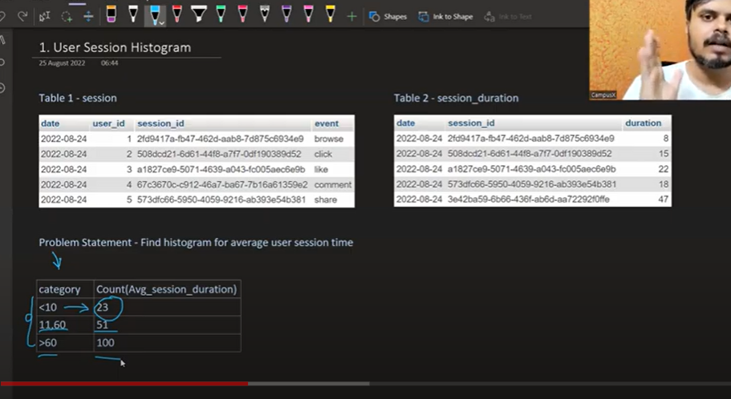

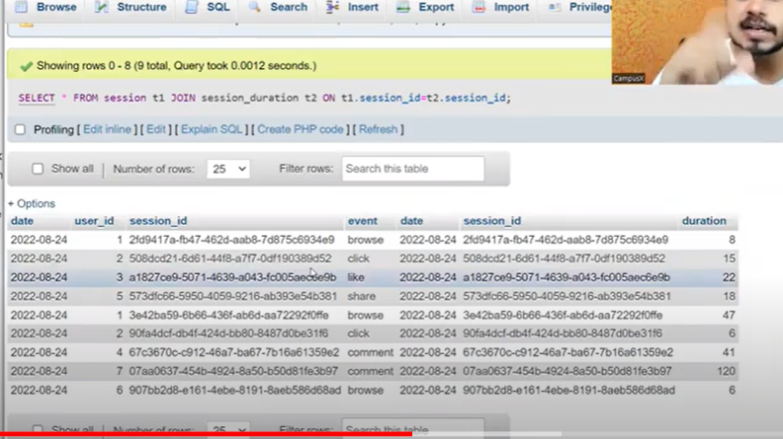

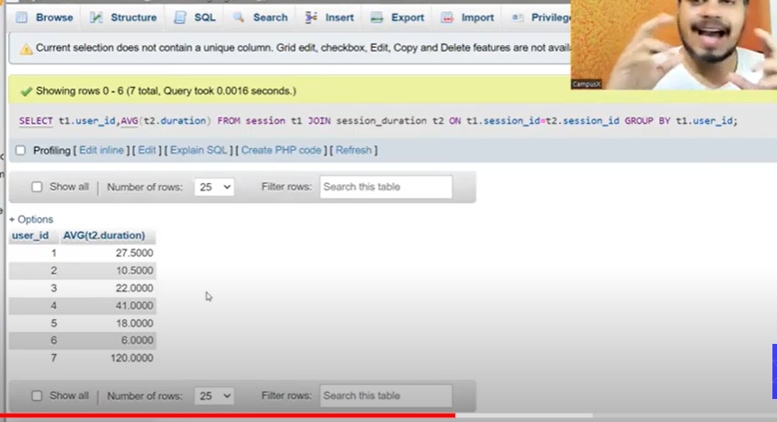

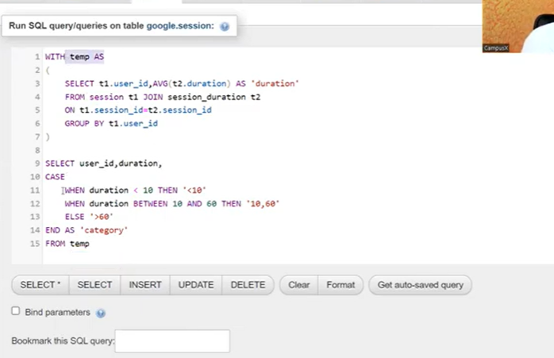

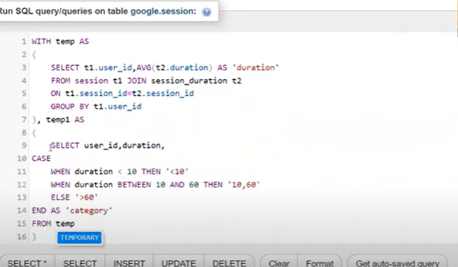

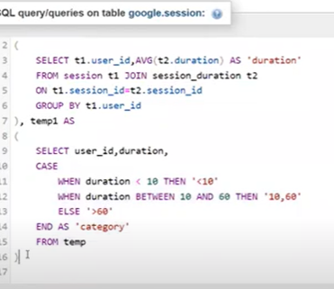

**Views in sql server**

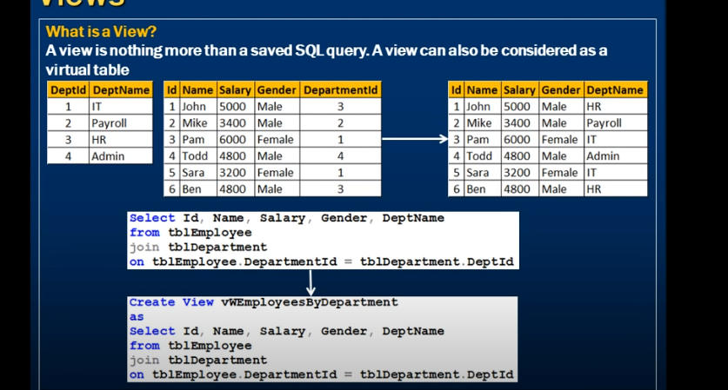

View is saved sql query

View can be a virtual table

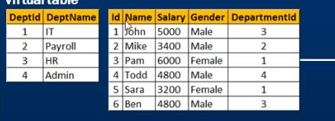

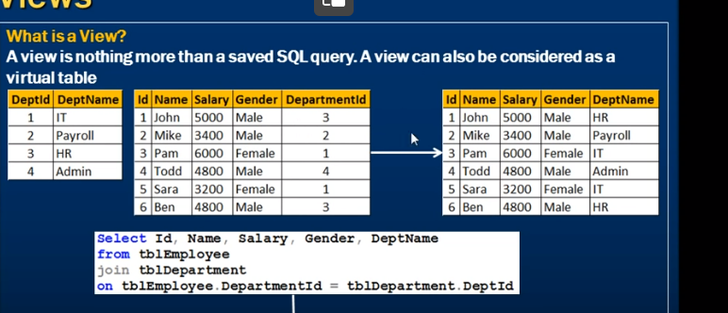

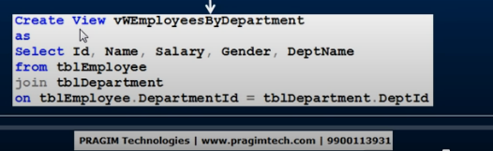

Vw

Once view created

How to see

Go to database \

Views folder

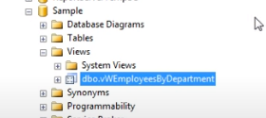

View can be treated like table

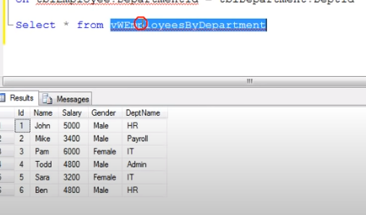

Text

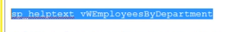

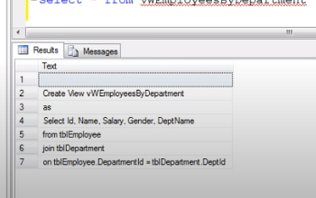

View is nothing but stored query

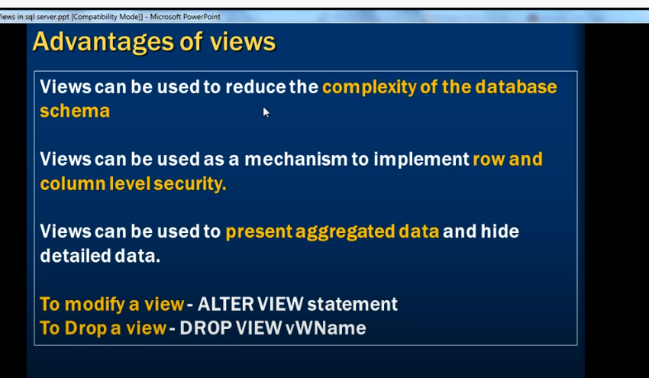

Decrease complexity of the database schema – non it users

Row and column level security

Hide detailed data

Can present aggregated data

**Updatable views in sql server Part 40**

Updatable views:

Salary is confidential employee

Instead of giving user access to table

We can create view with all columns except salary

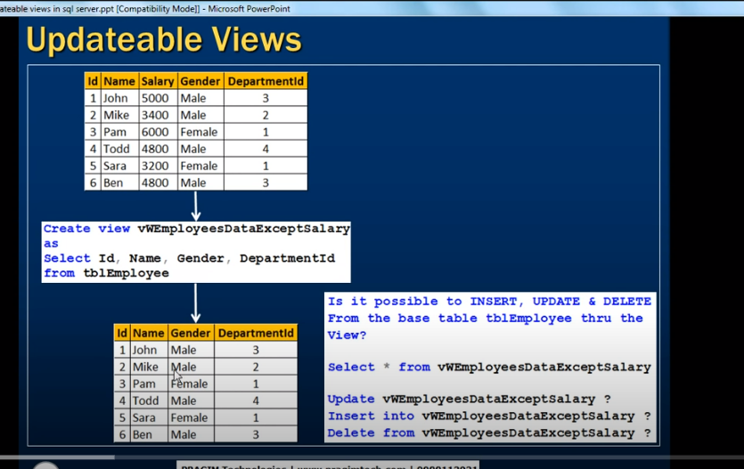

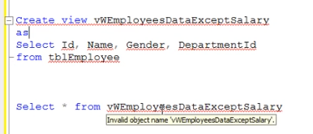

View doent store any data, its just a virtual table

Its not real table

When we execute view it gets data from underline base table

--

Can we update view?

Yes

It will update base tables

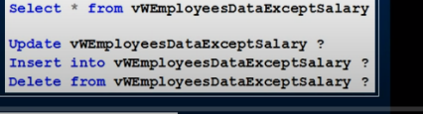

Vies are updatable

We can update delete , insert into views(changes in underline table)

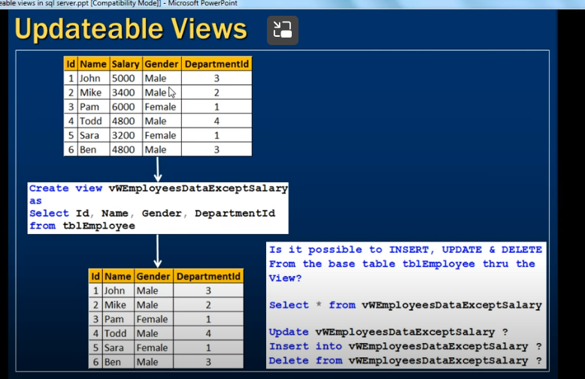

Above view is based on one table

--

If views are created from more than one table

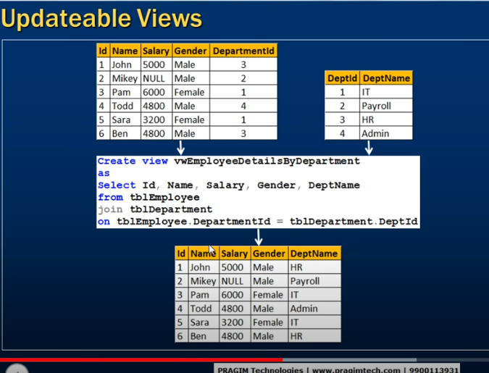

When we update view

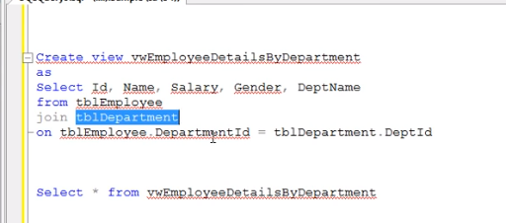

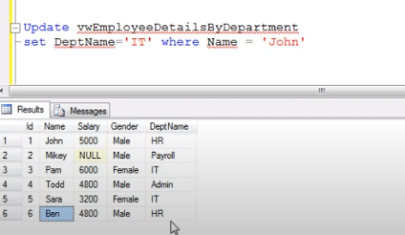

John is hr

Along with john ben also in hr

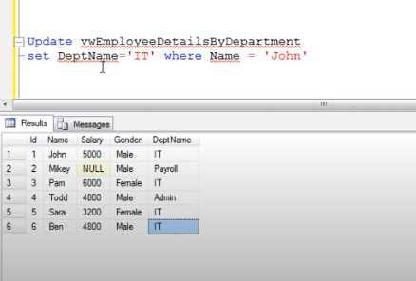

It updated ben also to IT

Why ben also get updated?

When we update ben dep

In dept table

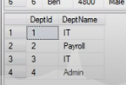

It- dept 3

View updates the dept table as well

--

If view is based on multiple tables: we must use triggers

**Indexed views in sql server**

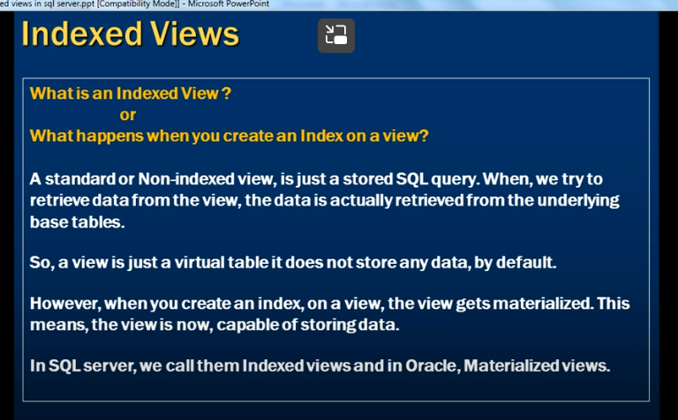

Standard or non indexed view: stored sql query, it wont store any data

When we try retrieve data from view- data gets from base table

Views : doesn’t store any data

Once we created index on view: materialized view, now it can store data

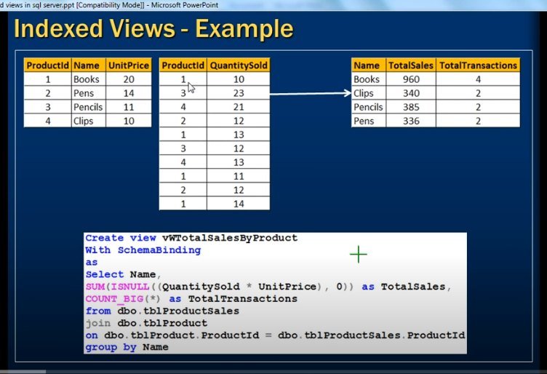

View should follow certain rules to be materialized

With schemabinding

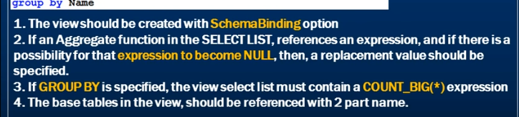

Dbo.table

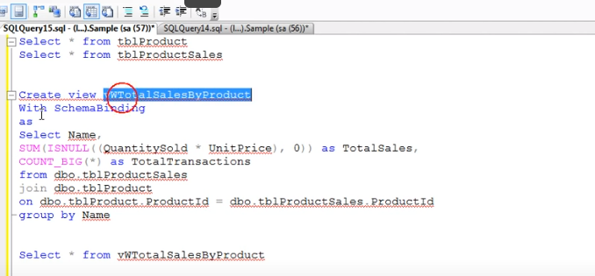

Everytime it must go to base table to calculate –

So we must create index on view

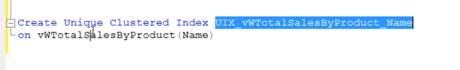

First index which we create on view should be unique cluster index

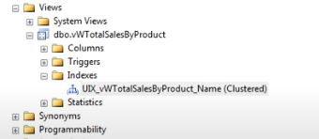

Now it doent require to go back to table to do calculation

Suitable for where data wont change

**View limitations in sql server**

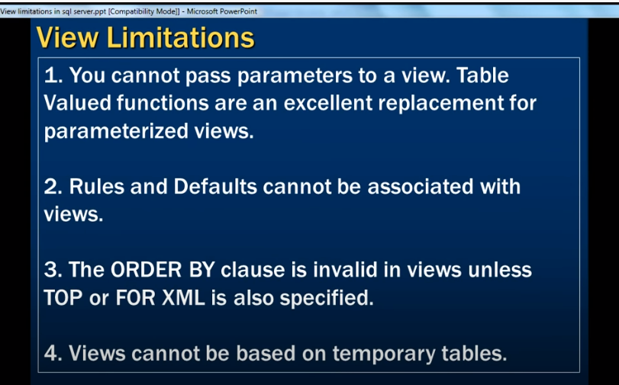

We cant pass parameters to view

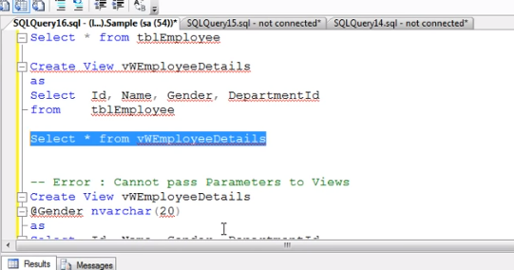

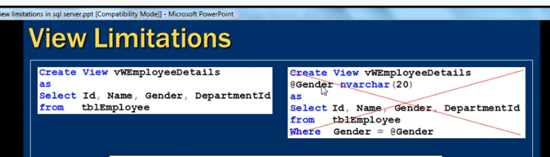

We are using parameter gender in right side

We cant do

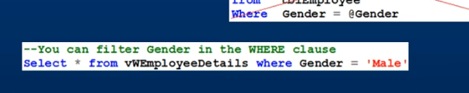

If we want to do, we can use **table valued function** n **replacement of parameterized views**

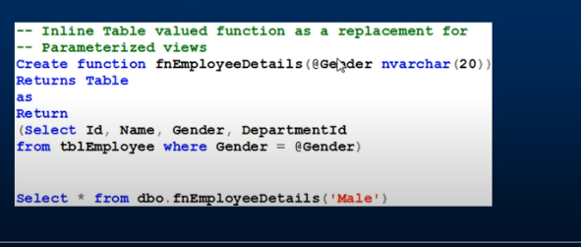

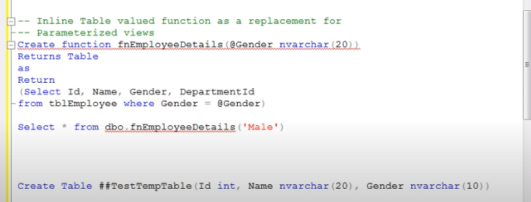

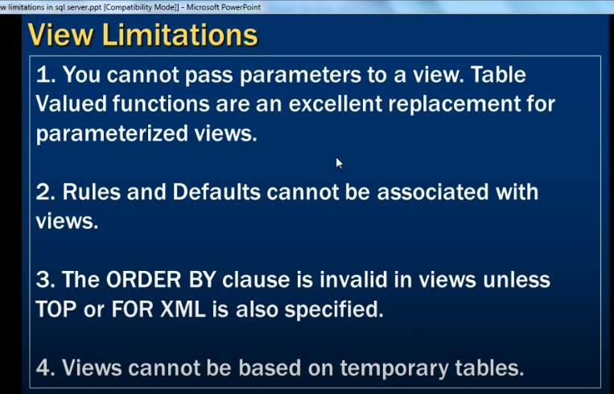

Rules and defaults cant be associated as they virtual table



Inviews definition wecant use order by

Unless top or for xml keywords specified

Views cant be based on temporary table

**DML triggers in sql server Part 43**

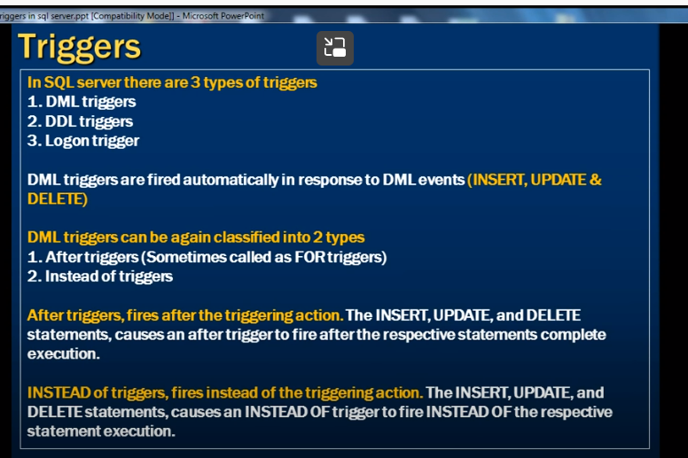

Dml:

Insert, update,delete

Dml triggers fire automatically in response to DML Events

2 types

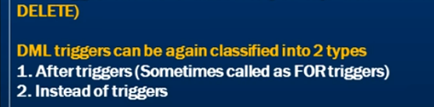

After triggers : they fire after an insert, update , delete statement execution

Instead of trigger: they fire instead of execution of an event

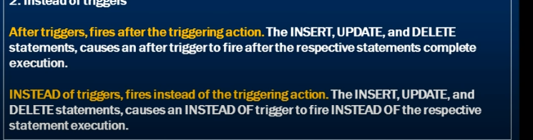

Triggers can be considered as special kind of stored procedures that responds automatically in response of a triggering action

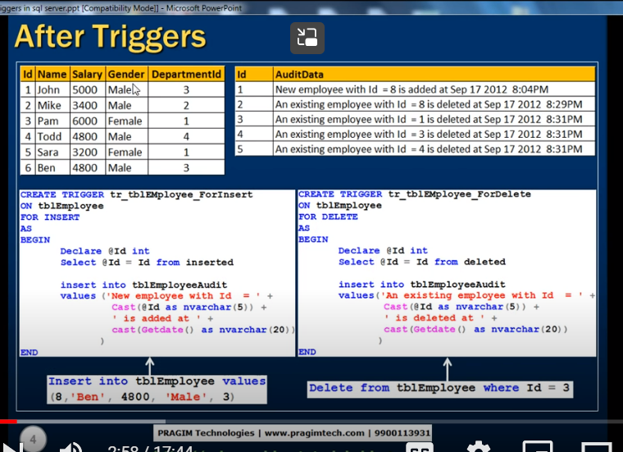whenever somebody insert a row into a table

It should automatically get captured in tbl audit table

Audit table has id and audit data

If I insert a row with id =8 – then audit table has info on update and date

For this we need to create a trigger associated with table

As soon as insert table executed on table it should fire trigger in audit table

Whenever we create trigger it should be on specific table and specific event (like insert)

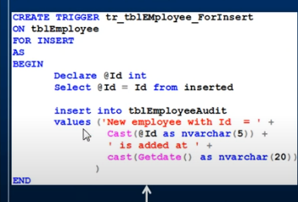

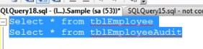

2 tables

One with data

2nd audit table is empty with 2 columns

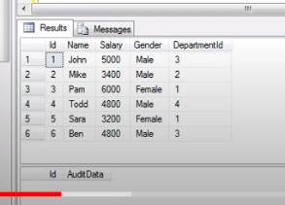

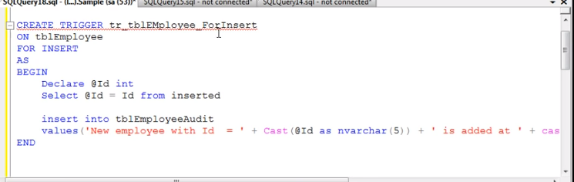

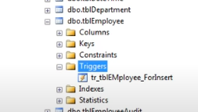

Trigger created

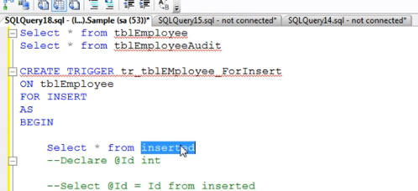

Inserted table a special kind of table will be available only in context of triggers

Whenever u inserted a row to table, that row will be also inserted into a inserted table created as a context of trigger

Inserted table structure identical to structure of original tables

We cant get access the inserted tables outside of trigger is not possible

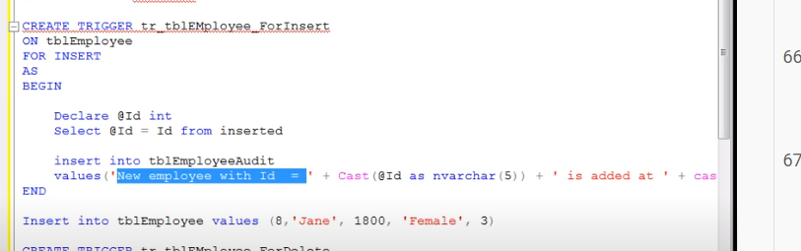

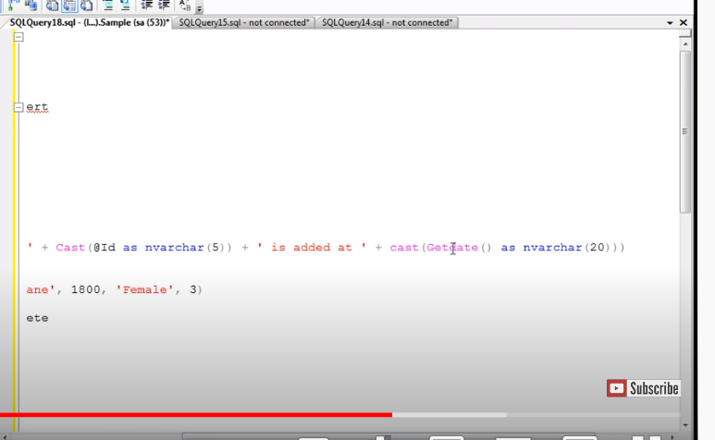

Insert a row



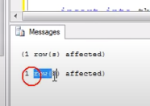

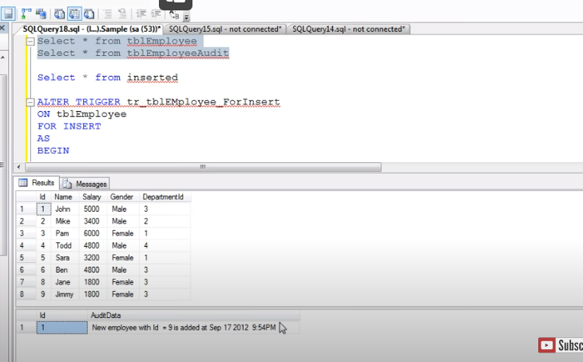

--

Delete trigger :

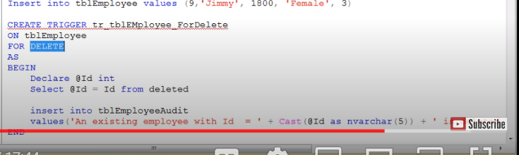

Instead of inserted table

Deleted table

Structure of table is identical to table

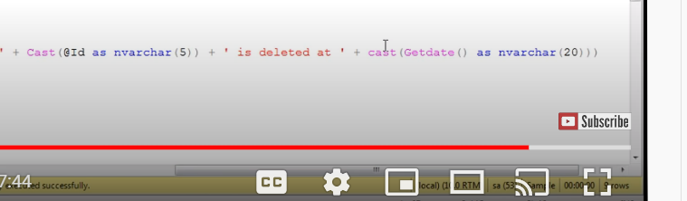

**After update trigger**

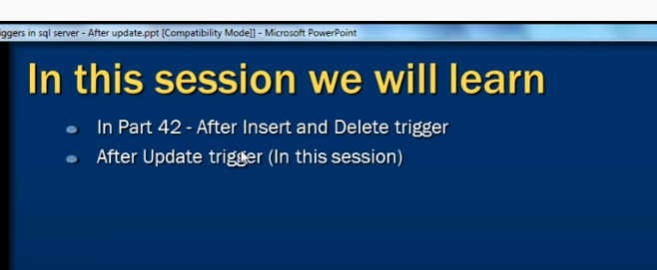

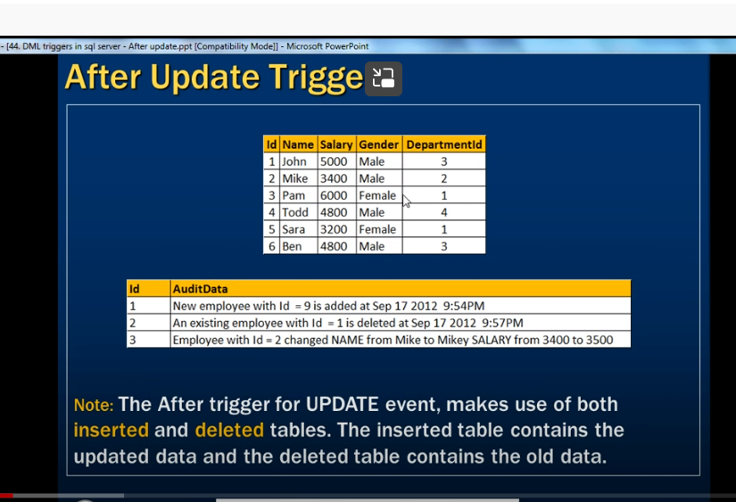

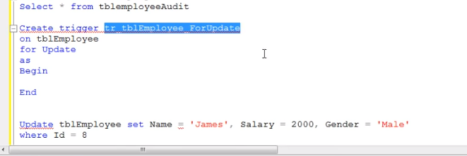

It uses bothe INSERTED and DELETE table

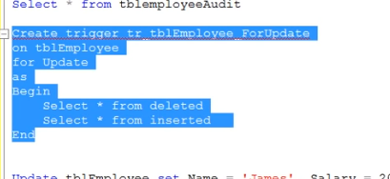

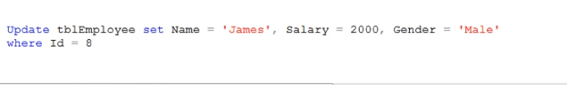

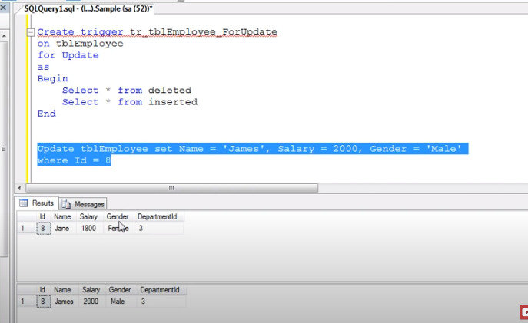

Deleted table contains data befr update

Inserted table contains new data

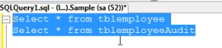

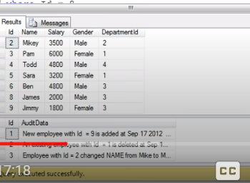

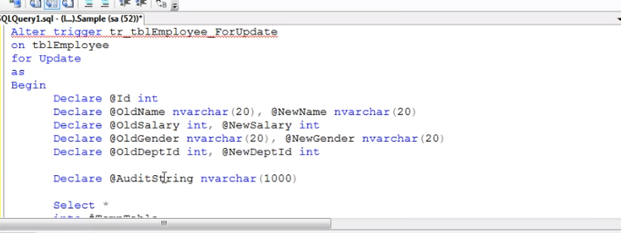

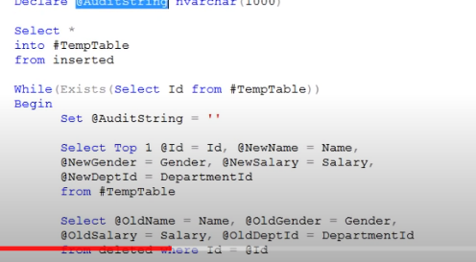

We have to insert data from inserted table to temporary table

Whenever someone updates : new data will be in inserted table

Put that in temporary table

Whenever we are updating many records at one time

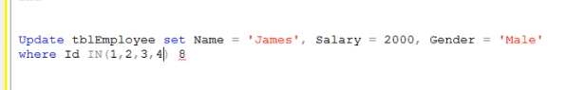

It should loop

Then store in temp table

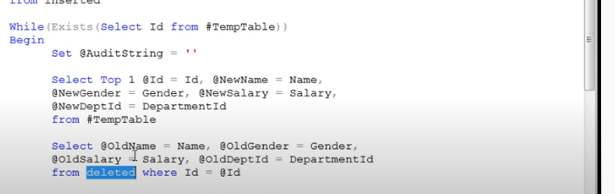

We compare old and new names

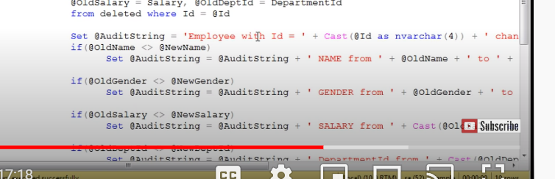

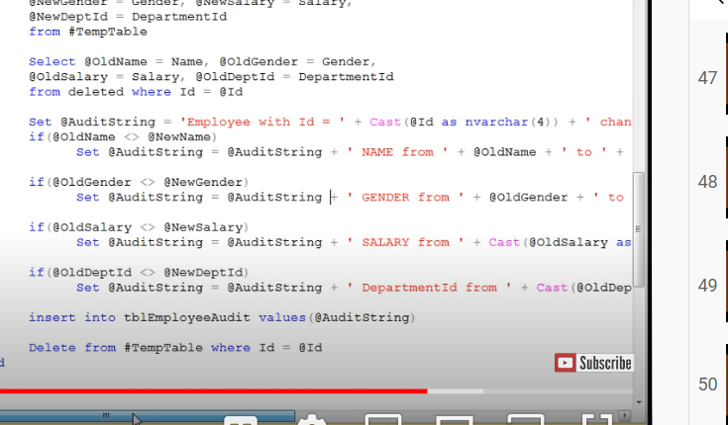

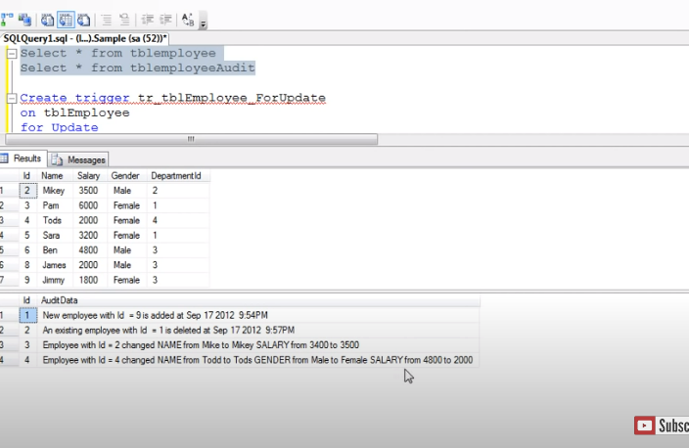

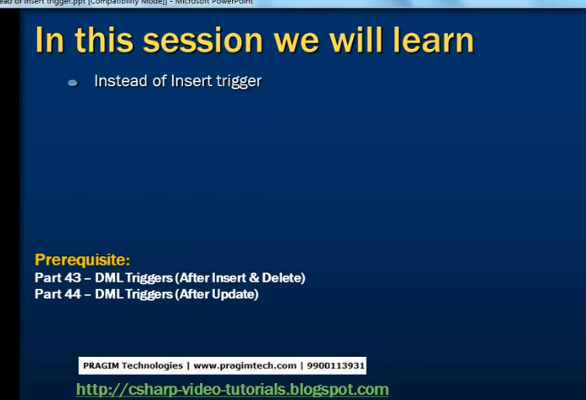

Instead of trigger

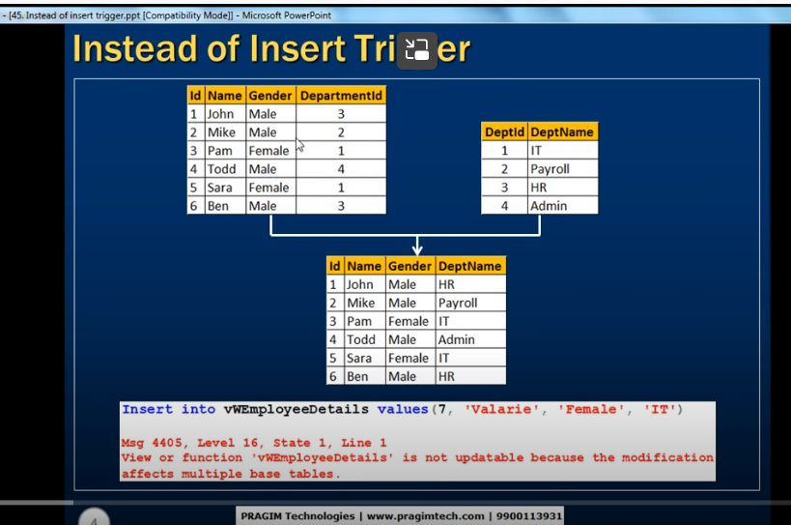

When I created view based of 2 tables

When I try to insert values into a view

We know view is virtual table doent contain any data

When we try insert row

It wil insert into base tables

Sql server has confusion which column should go which table

If insert tables effects more than one table – sql throw error

How to correct it

Instead of triggers used to update views correctly that’s based on multiple tables

--

First create view

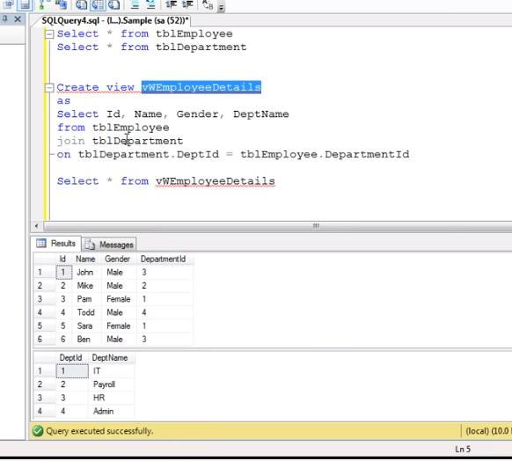

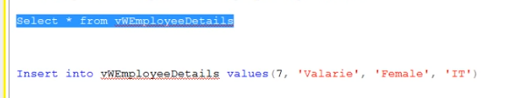

It wont get exceucted

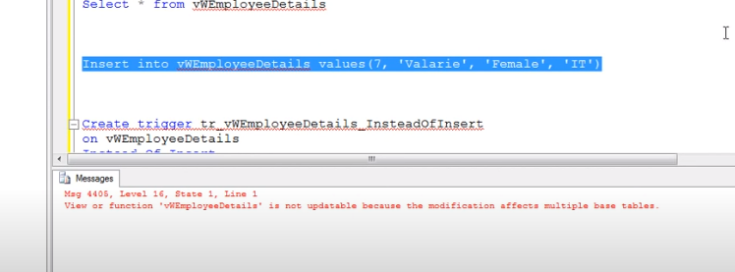

How to correct

We need to created instead of trigger

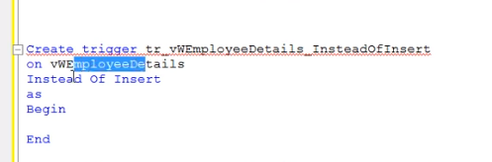

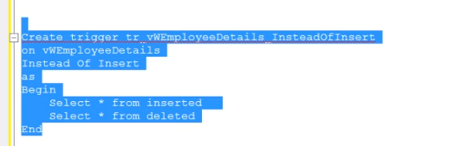

Inserted table and deleted table

Now insert’

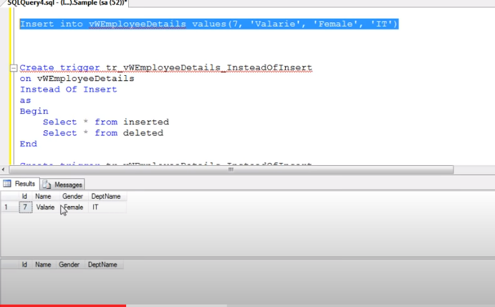

Now how can we create instead of insert trigger that can insert data into underline tables

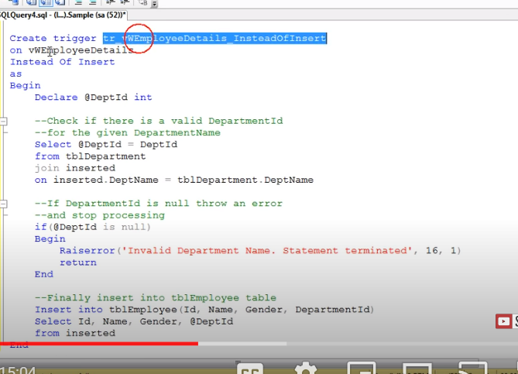

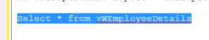

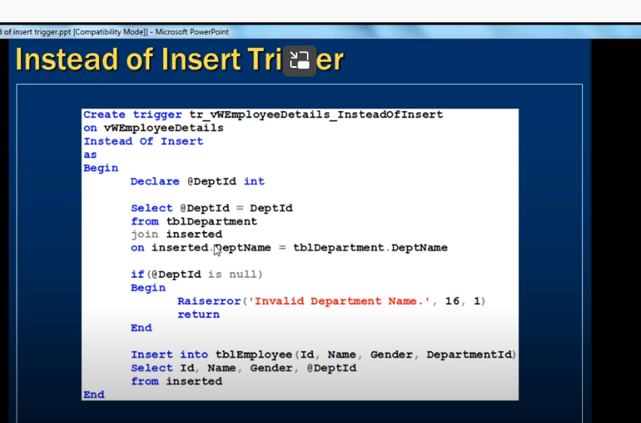

**Instead of update triggers in sql server**

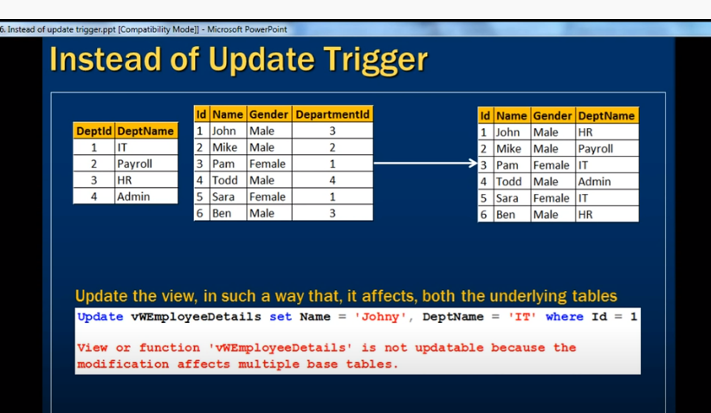

When view created based on two tables

When we update view – it doent allow as if effect multiple base tables we can overcome that by creating trigger called instead of update trigger

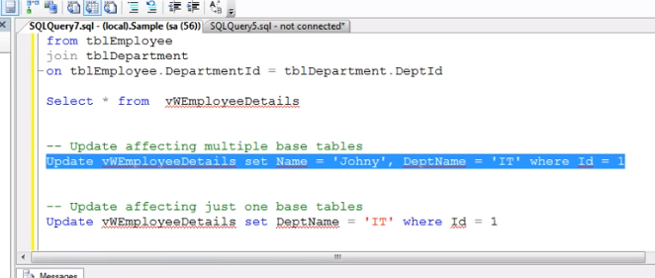

**Instead of delete triggers in sql server**

**Derived tables and common table expressions**

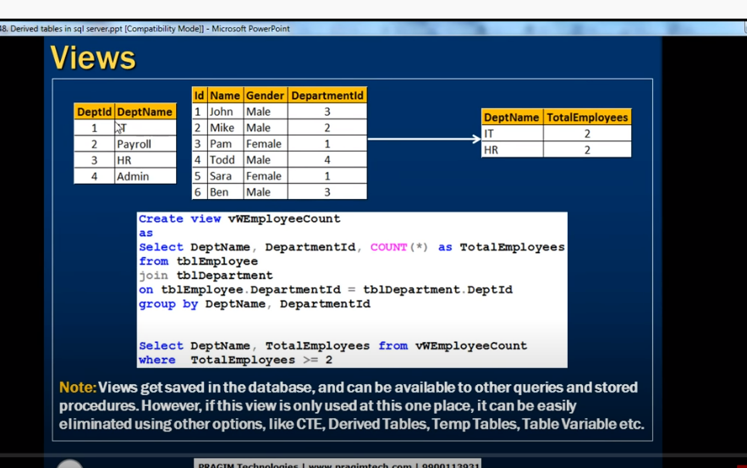

When we are using view only for this query is not useful

* One time doent make sense

We can achieve this by using temp tables

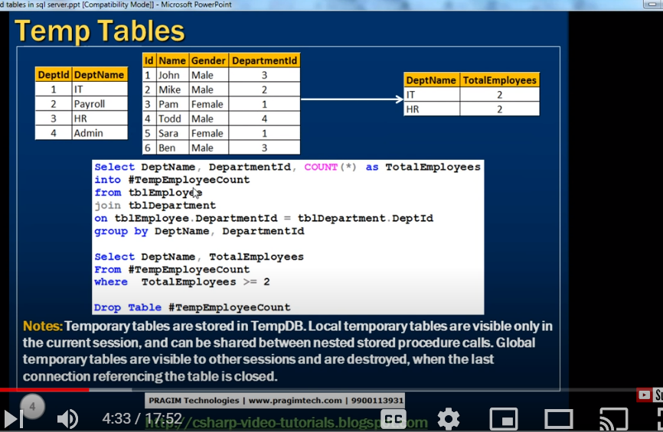

Selecting that data into temp table

Its better to delete temp table after its use

For temp table we don’t define structure

Structure will be created by select

--

Table variable

We need to created structure

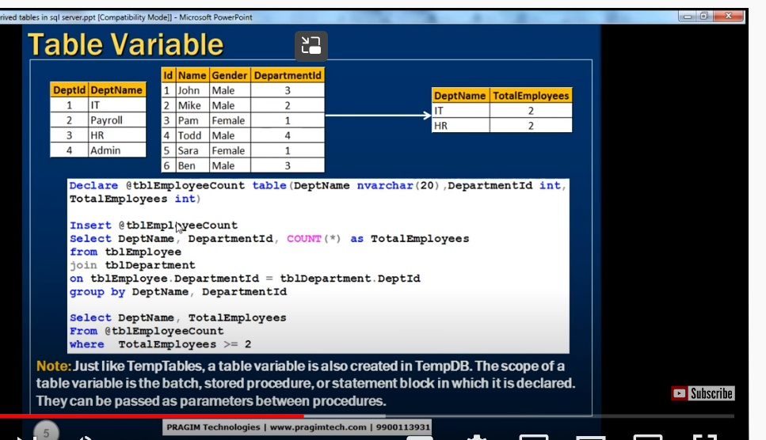

Teble variables are created in temp db

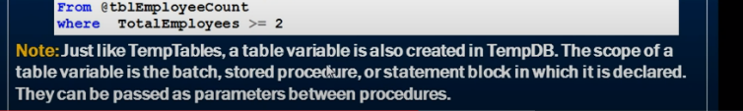

They can be passed as parameters between procedures

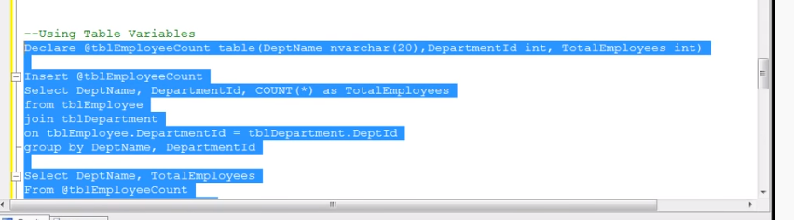

We no need to drop

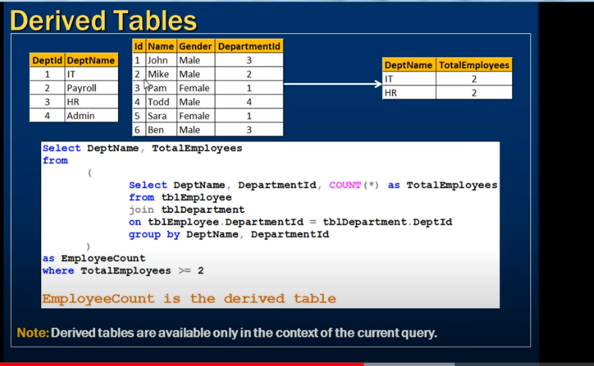

Derived table : we don’t need to defined table

Gave name as employeecount for that table

Inside subquety is derived table

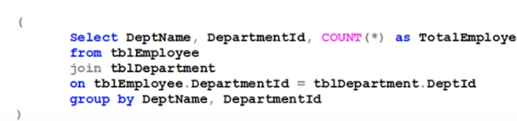

This is only available for this query

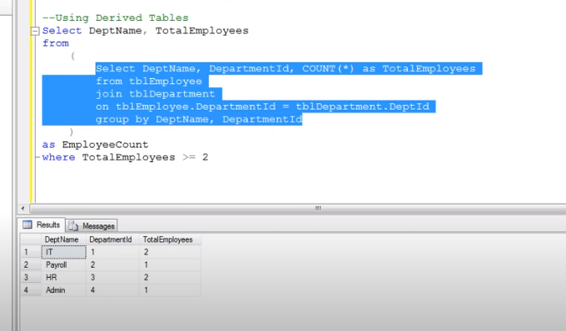

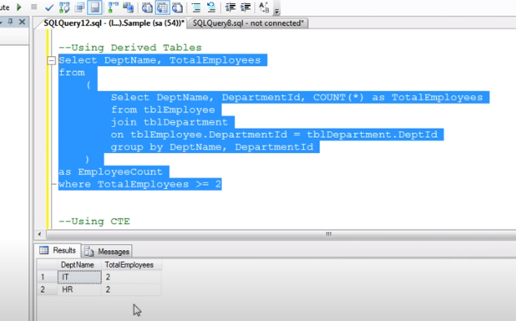

CTE;

COMMON TABLE EXPRESSION

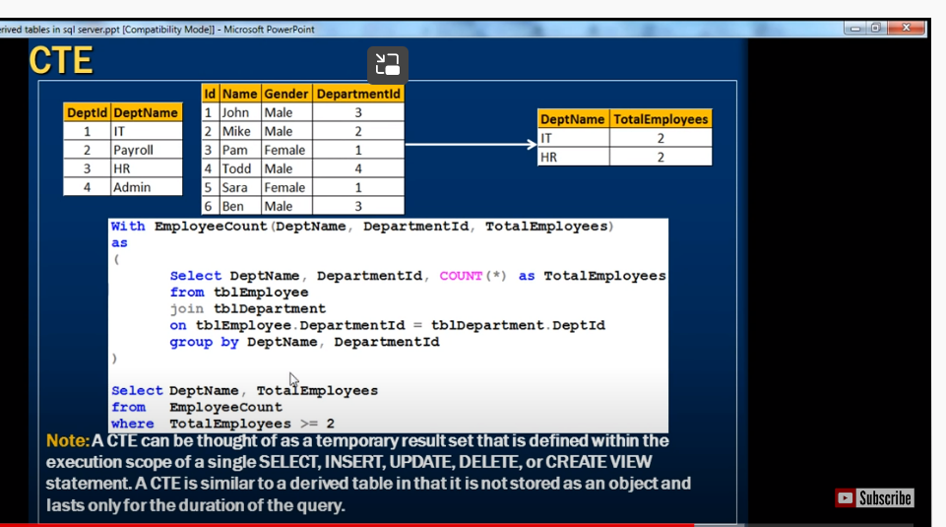

Same like derived table

It wont store

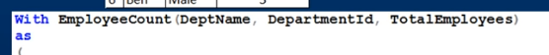

These columns coming from select statement

**CTE in sql server Part 49**

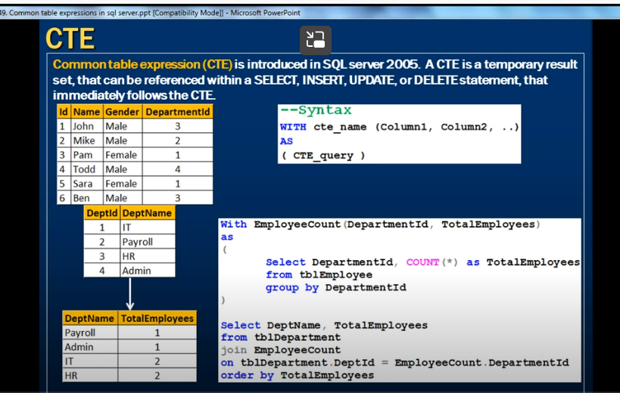

Cte is temporary results set